Ideation Phase
Define the Problem Statements
Date | 24 September 2022
Team ID | PNT2022TMID48099
Project Name | Project – Hazardous Area Monitoring for industrial Plant Powered by IoT
Maximum Marks | 2 Marks

Customer Problem Statement Template:
I am | Trying to Avoid Industrial hazardous accidents.
I’m trying to | Control and monitoring the hazardous area.
But | Many industry are not following the proper maintenance and services.
Because | Of maintenance cost high and awareness less of some industry.
Which makes me feel | We losses more employees life, industrial materials and industrial surrounding areas were polluted.

Reference: https://miro.com/templates/customer-problem-statement/ Example:
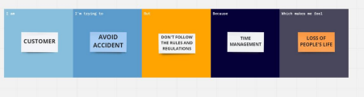
PROBLEM STATEMENTS
Problem  Statement  (PS) | Iam  (Customer) | I’m trying to | But | Because | Which makes me feel
PS-1 | We think  that to  avoid industria-l acciden-t | Prevent  Industrial hazardou-s accident | Rules are not followed by industr-y | Of less  awareness | To avoid pollution
PS-2 | To avoid  pollution | To avoid the human  Dead’s in industry | Not proper mainte-nenace | Careless  ness | We lose our industrial employees life

